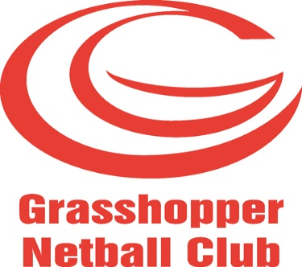 NEWSLETTER: SPRING 2020

Happy New Year to you all!
On behalf of your Committee, here is the latest news from Grasshopper Netball Club. Happy reading!
- Congratulations!
- To our Club for being a finalist in the Blaby District Council Sports Awards in November 2019; we were in the ‘Team of the Year’ category. We didn’t win, but we did receive recognition for our achievements and a ‘Highly Commended’ certificate. The event was held at the Marriott Hotel, Grove Park and was attended by myself (as Chair), Kathy Cox, Kate Garner and Sheila Oliver (see below).
- To our Club on being a finalist in the “Leicester Mercury” Sports Awards 2020 in the ‘Club of the Year’ category (we appeared in the ‘Leicester Mercury’ Sports Awards supplement on Monday 13 January 2020). This prestigious event was held at the Leicester Tigers’ ground on Thursday 16 January 2020 and representing Grasshopper NC was myself (as Chair), Andi Flewitt, Amy Hayes and Taz Dhanji - some of our longest-standing Club members – but I daren’t add up how many happy netballing years we have between us! Thank you to all for coming along to celebrate more success.
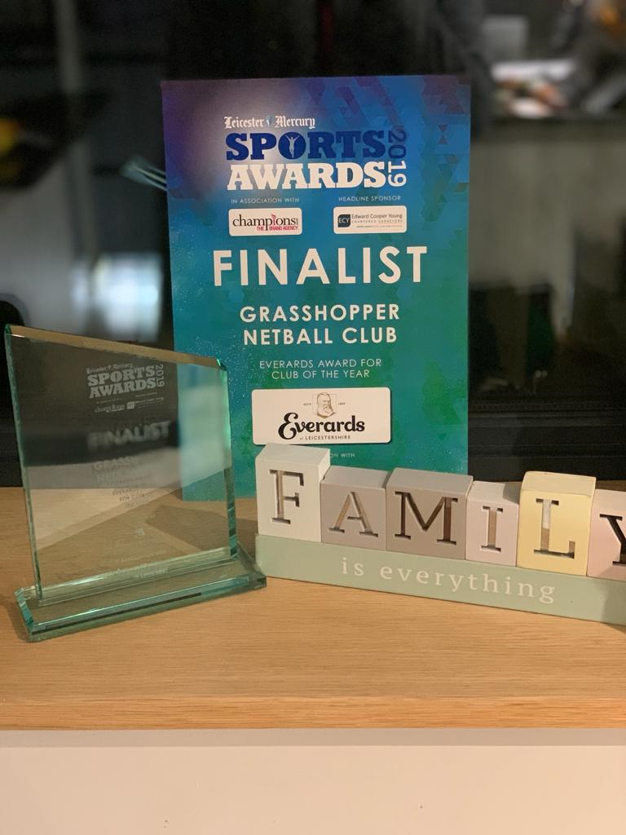
- England Netball’s ‘Goalden Globe’ season is upon us again and your committee will be looking once more to see where Club member nominations can be made for 2020.

- Trials
These took place as usual during August/September 2019 at Soar Valley and MASSIVE thanks must go to the committee members - and Kathy Cox in particular - for the sheer volume of work, time and effort that she put into this during my enforced absence (due to my Mum passing away in August 2019). Your committee members did a sterling job and proved to me that the Club will be left in safe hands once I finally decide to ‘hang up my trainers’!
Normally, we hold a annual Captains’/Selection Committee Review meeting in December, but declined to do so this year (but we did liaise with the captains) since we felt there was no need, with G1 & 2 sitting at the top of the Premiership, G4 sitting at the top of Division 1 and G5 sitting at the top of Division 2. Unfortunately, G3 have not fared so well, but earned their right to play in the Premiership from last season’s performance, but they will be relegated next year.
Speaking of next year (2020-2021) – could you please let your Captain know immediately your availability for the upcoming Summer League and for next season’s league teams with GNC; remember – whilst you are enjoying your summer holidays – some of us need to look at the ‘state’ of Club numbers and decide how many teams to enter next season. Personally, I would like to enter at least our 5 again if we can.
- Training 2019-2020 Season
Senior training is happening regularly at The Winstanley School, Kingsway North, Braunstone, LE3 on Wednesday evenings from 8.00-9.30 pm and our teams still rotate; HUGE thanks must go to Kate Garner and Donna Osborn for overseeing this, organising it and delivering a large part of it. However, we are also indebted to existing senior members and newcomers to the Club (from Bluetits) for also taking a session at regular intervals: Holly Walker, Beth Smith, Sarah Barber, Beats and Nadine Key. We realise that this new arrangement is not the ideal (it is a bit late in the evening), but it has helped the Club immensely this year by freeing up many more people to help out with our youth teams – of which there are now 6! From the help received at the training sessions above, it is evident that we are developing more Club members to consider obtaining their coaching award and grants are available from the East Midlands region or Leicestershire County Netball Association (Leicestershire Netball) or Grasshopper NC to help fund some of the cost.
Youth training has been taking place on Thursdays at Soar Valley and due to the sheer numbers of youngsters (we haven’t turned anyone away because otherwise they would have no opportunity to play netball), we have split the sessions: G4, 5 and 6 from 6.30-7.30 pm and G1, 2 and 3 from 7.30-8.30 pm most weeks. We are indebted to those senior members who attended the recent C Award Umpiring Course (Beth Smith, Katie Long, Amy Hayes and Shell Davis – a youth player Mum) and who have regularly committed to helping us to umpire the youth games each week before Christmas; they have also been supported by every single club committee member, Katie Clarke, Hazel Butler and Rosie Weselby (who did our recently organised ‘Into Officiating’ course and a recent ex-youth player) and many of our Bluetits newcomers eg, Jazz, Kalisha, Anna and Rachel B….. Another ex-youth player from about 10 years ago – Grace Duddy – has also been an extremely valued member of this youth official team too, as well as an ex-player from a long time ago – Linda Burman. I must not also forget the many parents from every team who have been there to support the girls by scoring/managing as well; they have also contributed to sustaining these 6 youth teams, but it would be great to see many more long-standing members giving up just 1 or 2 hours in a season to help us out. Finally, I must thank Donna Osborn for organising this ‘staffing rota’ for me and for helping me out with the Youth Training sessions, along with Kathy Cox. There are plenty of opportunities for you to help out still further next year – as enquiries from young people to join us are still dropping into my email box at a rate of 2/3 every week. If GNC doesn’t give these girls the opportunity to play competitive netball outside of school, then I don’t know where else they can go. PLEASE TAKE THE PLUNGE AND COME ALONG TO HELP OUT – I AM CONFIDENT YOU WOULD THOROUGHLY ENJOY SEEING THE JOY AND HAPPINESS ON THE GIRLS’ FACES
Finally, on the subject of training – please look at the website ‘Training’ tab regularly to check the venue – as there will be some changes over the coming weeks as the plan is to move to Brockington College in Enderby shortly, for a few weeks – still on Wednesdays, before using Soar Valley (on Thursdays when the youth are there) until the end of June.
Youth Teams
As reported above, we have entered 6 youth teams into the Leicester Netball Youth League and we have 3 in Division 1 and 3 in Division 2. The squads are large (circa 12 in each team), but the parents are helping with the duties, scoring or managing and they’re doing a great job. I am proud to have at least 14 schools represented in our youth set up from across Leicestershire - from private and state education - and many of our youngsters are studying GCSE PE or are doing the Duke of Edinburgh Award and Netball forms an important part of their education. We are contributing to their future.

On 11 January 2020, 19 of our youth players from G1, 2 and 3 teams were present at the East Midlands’ Coaching Conference at Loughborough University; they were the guinea pigs for the coaches in attendance (28). 10 of the girls were there from 9 am until 1.30 pm but another 9 of them were able to stay all afternoon until 5.30 pm!! The girls were a real CREDIT to our Club and to their parents as they listened well, behaved well, did as they were instructed by the Workshop Leaders (ex-England Netball Captain Olivia Murphy and International Coach, Joan Young) and worked extremely hard. I was SO proud of them all. For those of you like me, who don’t ‘do’ ‘facebook’ – check this out (below)!

Just last night (5.3.2020), Grasshopper 1 youth WON their Division 1 in the LNL Youth League – HUGE congratulations to them!
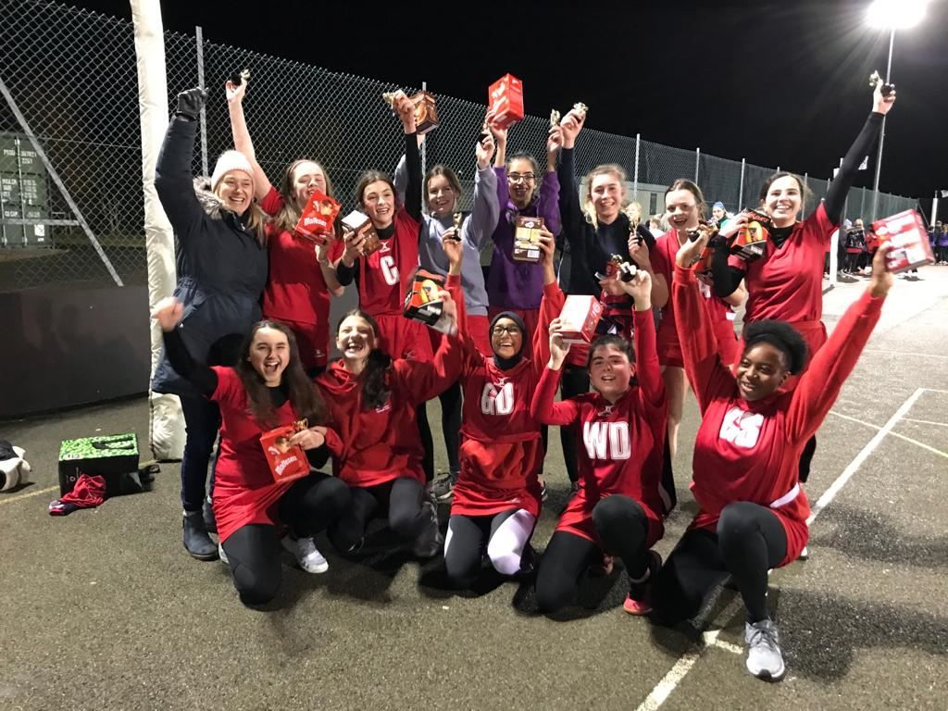

- First Aid Course & Into Officiating Course (in-house)
The ‘Into Officiating Course’ with Jo Stephenson took place in September 2019 at Soar Valley College and thanks to Kate Garner for taking over the organisation of this event in my absence. It was filled with our youth players, some seniors and other players from Hawks NC. This was a ‘first’ for us, but it was very successful – and useful to our youngsters doing DoE and GCSE PE. Hopefully, everyone who attended this course will continue to officiate over the coming months. I would like us to offer another of these and will gauge interest from our youngsters and existing members imminently.

- Website & Social Media
Hannah Wale continues to update all our social media sites on our behalf – thank you. If you have not done so – please read our Social Media Policy (on the website) and note that we should all be ‘signing up’ to this.

- Umpiring
Thanks again to Kathy Cox for all her excellent work with the new EN membership system and for sorting out this season’s Umpiring Rota – what a star! It is good to see Laura Benz back with us mentoring/umpiring after her recent Achilles’ tendon injury. Welcome back!

- Christmas Raffle
Thanks to Sheila Oliver for doing the huge amount of organising for this event. It was very successful and we raised £450.00 for the Club! Sheila must also be thanked for organising a very enjoyable Christmas meal at ‘Altro Mondo’ which included karaoke and was a very good evening and it was really good to see a mix of long-standing and new Club members at this event.
- Silly Sox & ‘Rainbows’ & ‘Air Ambulance’ Charities
Still on the subject of Sheila Oliver and her organisational prowess – we must thank her again for organising the ‘Silly Sox’ event at the LNL Tuesday night games. We raised a total of £243 and the Club made this amount up to £300. Thanks also to the LNL for allowing us to fund-raise on a Tuesday in their league.

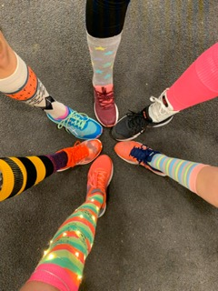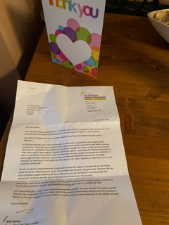

- Withers Sports – just a reminder that they will give all GNC members the following discounts:
  - 10% off a spend of up to £50
  - 15% off a spend of up to £100 and
  - 20% off a spend of over £100

- Important date for your diary!
Our AGM is being held at The Braunstone Civic Centre on Thursday 30 April 2020 – 7 pm prompt until 9 pm. Light refreshments are usually provided (from about 6.30 pm) for those coming straight from work. Please make every effort to attend, as this is your Club and we want you to feel that you can have your voice heard on important Club matters and on the future running and direction of this Club – one of Leicestershire’s oldest and finest netball clubs. If you have anything for the agenda, please let myself or any committee member know.

Thank you!

Andy Scigliano, Chairperson - on behalf of the Committee -
Grasshopper Netball Club
Spring 2020

